USAWC Department of distance education

Author: | Click Here, Then Type Author Rank/Title and Name
Course: | Click Here, Then Type Course Title
Requirement: | Click Here, Then Type Requirement Number
Date: | Click Here, Then Type Date  (dd Month yyyy)

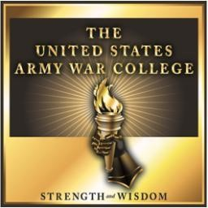

The U.S. Army War College is accredited by the Commission on Higher Education of the Middle States Association of Colleges and Schools, an institutional accrediting agency recognized by the U.S. Secretary of Education and the Council for Higher Education Accreditation.

The views expressed in this paper are those of the author and do not necessarily reflect the official policy or position of the Department of the Army, Department of Defense, or the United States Government.

U.S. Army War College
Carlisle Barracks, Pennsylvania 17013

Start typing here…

